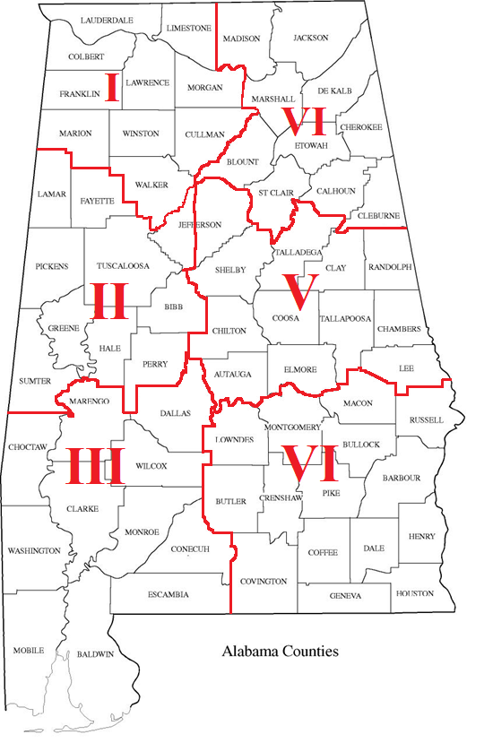
ALABAMA FBLA INTERACTIVE MAP
DISTRICT II
All city schools in Jefferson County:
Bessemer
Birmingham
Fairfield
Homewood
Leeds
Midfield
Mountain Brook
Tarrant
Vestavia Hills

DISTRICT V
All Jefferson County Board of Education

